Project Documentation
Health AI – Medical Assistant

1. Introduction
• Project Title : Health AI – Medical Assistant
• Team Member : SANKARI N
• Team Member : SIVARANJANI T
• Team Member : SRIBHARATHI K
• Team Member : SWATHY R

2. Project Overview
- Purpose :
The purpose of the Health AI Assistant is to provide an AI-powered system that can analyze user symptoms, suggest possible medical conditions, and generate personalized treatment plans. It demonstrates how AI can assist in healthcare awareness while emphasizing that final medical advice must always be taken from certified professionals.
- Features:
Conversational Interface – Natural language interaction to analyze symptoms and suggest treatments.
Disease Prediction – Predicts possible health conditions based on symptoms.
Treatment Plan Generator – Generates treatment guidelines, home remedies, and medication suggestions.
Gradio UI – Provides an easy-to-use interface with multiple tabs for interaction.

3. Architecture
Frontend (Gradio): Interactive UI with two tabs – Disease Prediction and Treatment Plan generation.
Backend (IBM Granite LLM): AI model used for natural language processing and response generation.
Libraries: Transformers, Torch, Gradio.

4. Setup Instructions
Prerequisites:
o Python 3.9 or later
o pip for installing packages
o Internet access for model downloads
Installation Process:
o Install dependencies using pip
o Load the Granite model and tokenizer
o Launch the Gradio application

5. Folder Structure
Health_AI.ipynb – Jupyter notebook with full implementation.
Functions: generate_response, disease_prediction, treatment_plan.
Gradio Interface: Tabs for Disease Prediction and Treatment Plans.

6. Running the Application
- Install required dependencies.
- Run the notebook to start the Gradio interface.
- Use Disease Prediction tab to input symptoms and view conditions.
- Use Treatment Plan tab to input details and get a treatment plan.

7. API Documentation
Functions available:
generate_response(prompt) – Generates AI-based responses.
disease_prediction(symptoms) – Returns possible health conditions and general advice.
treatment_plan(condition, age, gender, history) – Generates a personalized treatment plan.

8. Authentication
This version runs without authentication. Future enhancements may include:
- Token-based authentication (JWT or API keys)
- OAuth2 for secure login
- Role-based access control

9. User Interface
The interface includes:
Tabbed sections for Disease Prediction and Treatment Plans
Input fields for symptoms, condition, age, gender, and history
Real-time response generation with AI

10. Testing
Testing methods:
Unit Testing – For functions like generate_response and prediction modules.
Manual Testing – For Gradio app workflows and user interactions.
Edge Case Testing – Empty input, incomplete details, and invalid values.

11. Screenshots

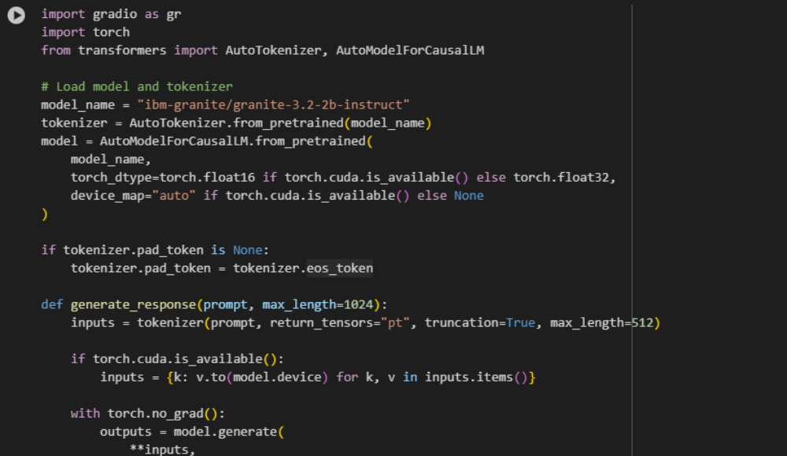

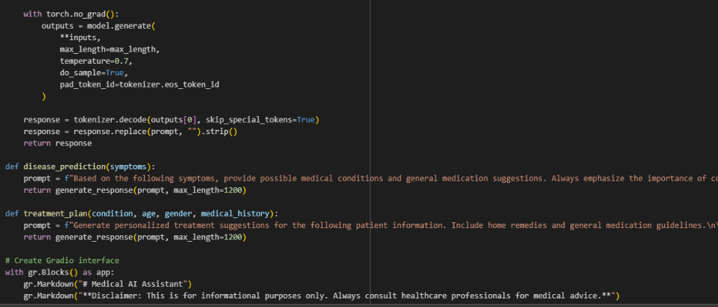
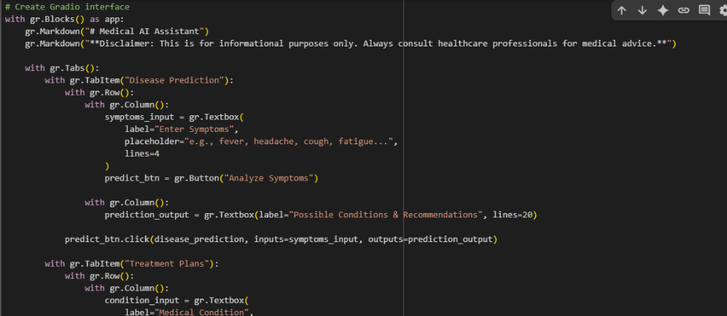

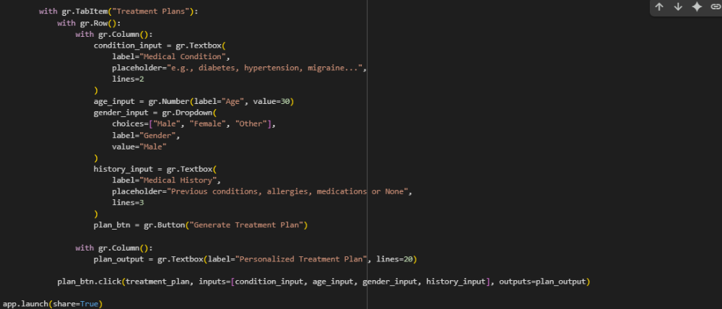

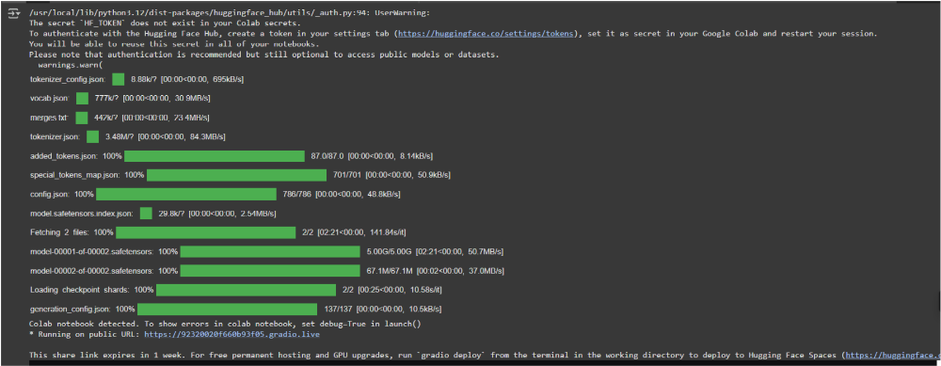
OUTPUT:
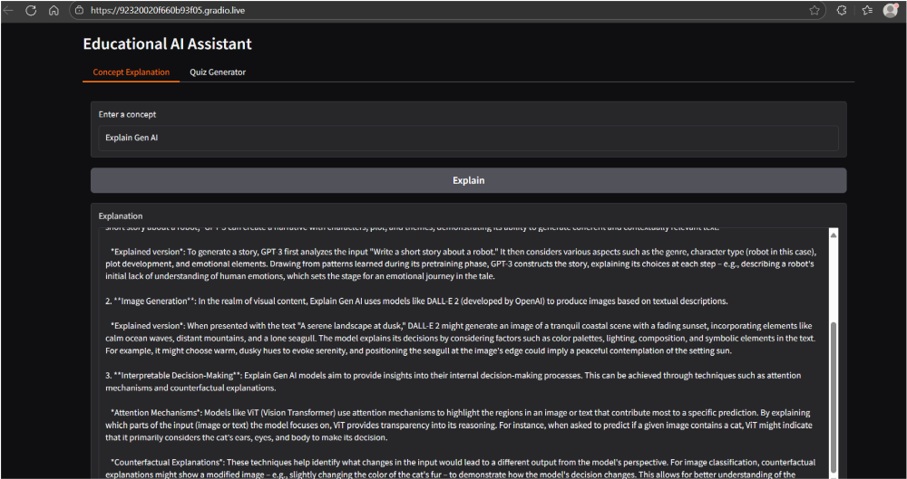

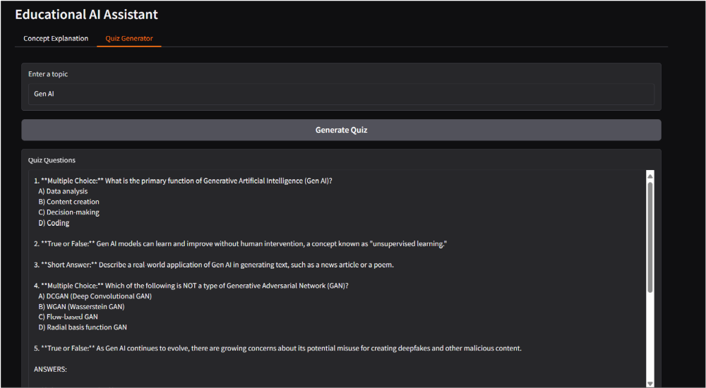

12. Known Issues
- Model provides general medical guidance, not expert-certified advice.
- Summaries and recommendations may vary based on model training data.
- Gradio UI customization is limited.

13. Future Enhancements
- Add secure authentication for privacy.
- Integrate certified medical datasets for accurate results.
- Support additional languages.
- Add graphical health insights and progress tracking.

